BUNDELKHAND UNIVERSITY, JHANSI

Department of Mathematical Science and Computer Applications

Resort Management System
Software Requirement Specification

Web Technology
Project

Date of Submission: 11-03-2022

Submitted by:
Nitesh Sahu
MCA – III sem
Roll N0. 201345098032

Submitted to:
Dr. Sonam Seth

Table of Contents

Table of Contents ii
Revision History ii
1. Introduction 1
1.1 Purpose 1
1.2 Document Conventions 1
1.3 Intended Audience and Reading Suggestions 2
1.4 Product Scope 2
2. Overall Description 3
2.1 Product Perspective 3
2.2 High Level Architecture 4
2.3 Functional Requirements 5
2.4 User Classes and Characteristics 7
2.5 Technology used for developing the Software 9
2.6 User Documentation 10
2.7 Assumptions and Dependencies 10
3. System Features 11
3.1 E-R Diagram 11
3.2 Use Case Diagram 12
3.3 Use Case Scenarios 13
4. Other Nonfunctional Requirements 27
4.1 Performance Requirements 27
4.2 Safety Requirements 27
4.3 Security Requirements 27
4.4 Software Quality Attributes 27
4.5 Other Requirements 28
5. Screenshot of the Website 29
5.1 Home page 29
5.2 Sign Up Page 32
5.3 Sign In Page 32
5.4 About Us Page 33
5.5 Team Member of Resort 34
5.6 Contact Us Page 36

Revision History
Name | Date | Reason For Changes | Version

Introduction

Purpose
The Software Requirements Specification (SRS) will provide a detailed description of the requirements for the Resort Management System (RMS). This SRS will allow for a complete understanding of what is to be expected from the newly introduced system which is to be constructed. The clear understanding of the system and its func0tionality will allow for the correct software to be developed for the end user and will be used for the development of the future stages of the project. This SRS will provide the foundation for the project. From this SRS, the Resort Management System can be designed, constructed, and finally tested.
This SRS will be used by the system development team which is constructing the RMS and the Resort end users. The Project team will use the SRS to fully understand the expectations of this RMS to construct the appropriate software. The Resort end users will be able to use this SRS as a “test” to see if the constructing team will be constructing the system to their expectations. If it is not to their expectations the end users can specify how it is not to their liking and the team will change the SRS to fit the end users’ needs.

Document Conventions
The document is prepared using Microsoft Word 2016 and has used the font type 'Times New Roman'. The fixed font size that has been used to type this document is 12pt with 1.5 line spacing. It has used the bold property to set the headings of the document. Use case scenario is written according to Alistair Cockburn’s template. UML (Unified Modeling Language) diagrams have been created according to UML 2.0 standards. Standard IEEE template is the template used to organize the appearance of the document and its flow.

Intended Audience and Reading Suggestions
The intended audience of this document would be owner and specific employees like Manager and Receptionist of Resort The Flores Resort, and project team with the objective to refer and analyze the information. The SRS document can be used in any case regarding the requirements of the project and the solutions that have been taken. The document would finally provide a clear idea about the system that is building.

Product Scope
The introducing software, Resort Management System which is going to be implemented for Resort The Flores Resort will automate the major operations of the Resort. The Reservation System is to keep track in room and hall reservation and check availability. The Room Management System is for manage all room types room services. The Inventory Control System will keep track in all inventories of the Resort and guest details will handled by guest management. Administration department will monitor the all. There is three End Users for RMS. The End Users are Owner, Manager and Receptionist. Owner can access to all system functionalities without any restrictions. Manager can access to all system functionalities with limited restrictions. Receptionist can only access to the Reservation management section. To keep restrictions for each End User levels RMS can create different Login functions.

The objectives of the automated Resort Management System is to simplify the day to day processes of the Resort. The system will be able to handle many services to take care of all customers in a quick manner. As a solution to the large amount of file handling happening at the Resort, this software will be used to overcome those drawbacks. Safety, easiness of using and most importantly the efficiency of information retrieval are some benefits the development team going to present with this system. The system should be user appropriate, easy to use, provide easy recovery of errors and have an overall end user high subjective satisfaction.

Overall Description

Product Perspective
The Resort Management System is a new self-contained software product which will be produced by the project team in order to overcome the problems that have occurred due to the current manual system. The newly introduced system will provide an easy access to the system and it will contain user friendly functions with attractive interfaces. The system will give better options for the problem of handling large scale of physical file system, for the errors occurring in calculations and all the other required tasks that has been specified by the client. The final outcome of this project will increase the efficiency of almost all the tasks done at the Resort in a much convenient manner.

High Level Architecture





Manager
View
Insert
Update
Delete
Add
Update
Delete
Add
Update
Reports
Department Details
Department Details
Department Details
Room/Staff/Inventory Details
Room/Staff/Inventory Details
Room/Staff/Inventory Details
Guest Details
Guest Details
Delete
Guest Details
Search
Rooms
Make
Reservations
Owner
Receptionist
Issue
Bill

Figure 2.1.1 High Level Architecture

Functional Requirements

Function 1 | Make Reservations
Input | Code, Number of children, Number of adults, check-in date, check out date, status, Number of nights
Output | Database Record, Database successfully updated message
Processing | Validate the given details and record the information in to the database.

Function 2 | Add Guest
Input | Member code, Phone number, Name, E-mail, Gender, Address
Output | Database Record, Database successfully updated message
Processing | Validate the given details and record the information in to the database.

Function 3 | Add staff member
Input | Code, Employee Name, Employee Address, Salary, Name Age, Occupation, E-mail
Output | Database Record, Database successfully updated message
Processing | Validate the given details and record the information in to the database.

Function 4 | Search Rooms
Input | Period, Check-in, Check-out, Guest
Output | Display a message with available room details
Processing | Validate the given details and check for the available rooms in a given time period and return it’s availability.

Function 5 | Add Payments
Input | Total, pay time, Credit card details
Output | Database Record, Database successfully updated message
Processing | Validate the given details and record the information in to the database.

Function 6 | Issue Bill
Input | Billing no, Quantity, Price, Taxes, Date, Services, Unit
Output | Printed version of the bill
Processing | Validate the given details and total cost is calculated according to the  Services gain by the customer.

Function 7 | Set Rates
Input | Check-in, Check-out, Day, No. of guests, First night price, Extension price
Output | Database Record, Database successfully updated message
Processing | Validate the given details and record the information in to the database.

Function 8 | Taking Backups
Input | Location to save the backup file
Output | Display a message showing backup successfully created
Processing | Validate the user given location to save the backup file. Save the backup file to the user specified location

User Classes and Characteristics

User Classes
There are three user levels in Resort Management System of Resort The Flores Resort.

- Owner
- Manager
- Receptionist

Characteristics of User Classes
Owner:-

Resort owner has the privilege of Monitoring and authorization of all the tasks handle by the system. He can access every function performed by the system. Owner of the company as well as the system can access to the administration panel which is consider the core of the system. As the main authorized person of the company owner gets the ability to manage the other users including their user levels and privileges. Taking backups of the system and restoring system can also be done by the Owner. Meanwhile he will be able to take all the kinds of reports available in the system. As the owner of the system and the company he has the power to set room rates as well. Resort owner has the sole right of deleting a staff member from the system database.

Manager:

Manager is responsible for managing resources available in Resort management system. Manager also has most of the privileges mentioned above except the things regarding the payment handling. The reason for using a Manager is to reduce the work load done by the owner that cannot be assigned to the receptionist, as those tasks seem much responsible. The user level, Manager has the authority to take all the reports available in the system but here also except the reports related to financial stuff, Resort income. Manager has other abilities that receptionist, user level has. Such as, adding new staff member to the system, Modifying them or removing them, Adding new guests to the system, Modifying them and removing them from the system, Adding new inventory to the system, Modifying them and removing them. Adding new room types to the system, modifying them and removing them

Receptionist:

As a Resort receptionist, he or her role will be to attain the goals of bookings and to ensure that all guests are treated with a high standard of customer service. Hierarchically receptionist role has the least accessibility to the system functions. Receptionist plays the boundary role of the system .He or she can perform limited functions such as registering new guest to the system, make reservations, Sending e-mail reminders to clients for booking confirmation. Management of Resort will prefer to hire receptionist who have a good standard of general education and possibly in subjects such as English, math and IT.

Technology used for developing the Software

Hypertext Mark-up Language (HTML)
HTML is the standard markup language for documents designed to be displayed in a web browser. HTML describes the structure of a Web page. It can be assisted by technologies such as Cascading Style Sheets (CSS) and scripting languages such as JavaScript. HTML elements are the building blocks of HTML pages. HTML elements tell the browser how to display the content.

Cascading Style Sheets (CSS)
Cascading Style Sheets (CSS) is a style sheet language used for describing the presentation of a document written in a markup language such as HTML.[ CSS is a simple mechanism for adding style (e.g., fonts, colors, spacing) to Web documents. CSS is designed to enable the separation of presentation and content, including layout, colors, and fonts

JavaScript
JavaScript often abbreviated JS, is a programming language that is one of the core technologies of the World Wide Web, alongside HTML and CSS. Over 97% of websites use JavaScript on the client side for web page behavior, often incorporating third party libraries. All major web browsers have a dedicated JavaScript engine to execute the code on users' devices.

MySQL
MySQL is an open-source relational database management system (RDBMS). Its name is a combination of "My", the name of co-founder Michael Widenius's daughter, and "SQL", the abbreviation for Structured Query Language. A relational database organizes data into one or more data tables in which data types may be related to each other; these relations help structure the data.

User Documentation
User manual provide to the client will give a clear idea in interacting with the system. It will be written in a simple understandable language concealing the inner complexity of the system. A hard copy of the user manual will be delivered to the client with the delivery of system.

Assumptions and Dependencies
Some software used in implementing the system is with high cost and the client has agreed to afford the amount of money needed to purchase them. It’s assumed that client won’t change that decision on the next phases of the software development. Although we assume that client is using windows 7 or windows 10. Otherwise if client use an open source operating system, there is a need of changing the SRS accordingly.

System Features

E-R Diagram
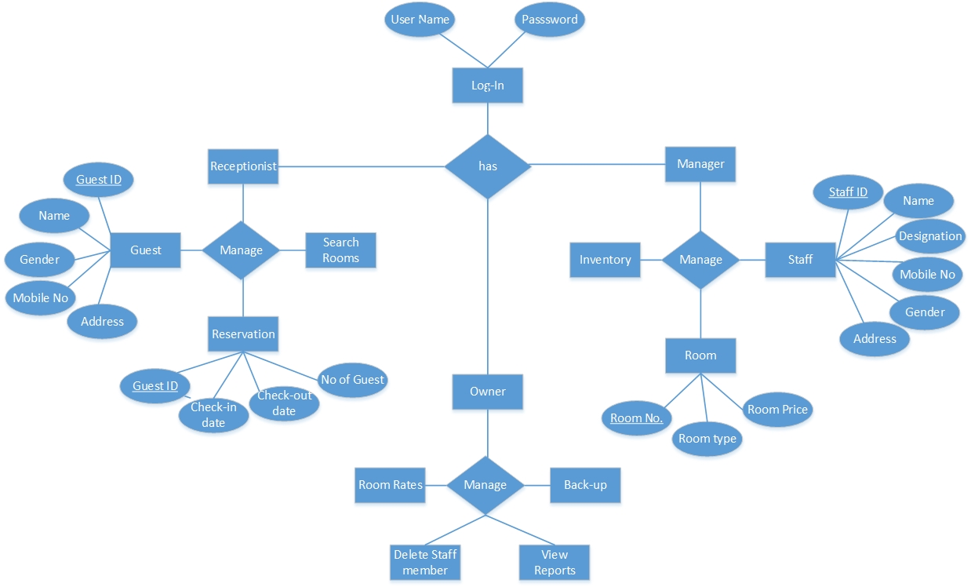

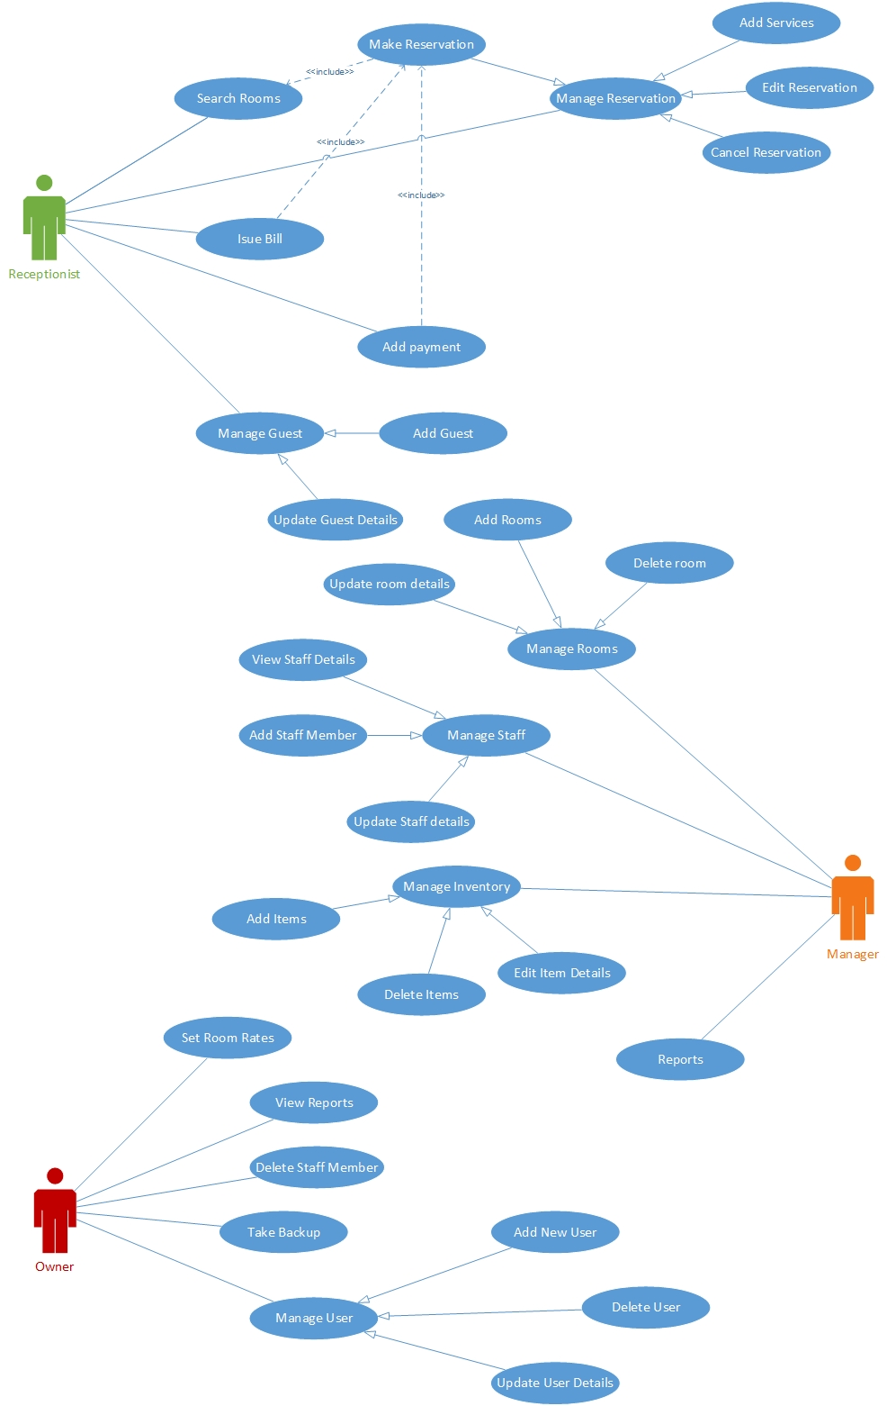
Use Case Diagram

Use Case Scenarios

1)

Use case Name | Make Reservation
Goal | Add a new reservation
Primary Actors | Receptionist
Secondary Actors | None
Precondition | Guest shouldn’t already be exist
Post condition | Resort Guest Details updated to include current Guest
Triggers
Main flow | Step | Action
 | 1 | Receptionist enter guest details
 | 2 | System searches for room details
 | 3 | System presents room types and tariffs
 | 4 | Customer selects room and confirms tariff
 | 5 | System records customer’s name and address
 | 6 | receptionist confirms booking on system
 | 7 | System generates confirmation receipt
Extensions

2)

Use case Name | Check Availability
Goal | To check whether a room available or not
Primary Actors | Receptionist
Secondary Actors | None
Precondition | Login to the system.
Post condition
Triggers
Main flow | Step | Action
 | 1 | Display User interface
 | 2 | Select Availability Tab
 | 3 | Enter room type, duration, number of adults and children
 | 4 | System check room availability relevant to each requirements
 | 5 | Display available room details
Extensions | 4.1 | No room available for entered details and display “No Room Available”

3)

Use case Name | Add Guest
Goal | Add a new Guest
Primary Actors | Receptionist
Secondary Actors | None
Precondition | Log in to the system
Post condition
Triggers
Main flow | Step | Action
 | 1 | Receptionist selects “add guest” button
 | 2 | System prompts to fill out guest details
 | 3 | System validates details
 | 4 | Update database
 | 5 | Display “Successful message”
Extensions

 | 3.1 | Guest details are incorrect, Display the message "Unsuccessful" and display Add guest option.

4)

Use case Name | Add Room
Goal | Add a new room to the system
Primary Actors | Manager
Secondary Actors | None
Precondition | Log in to the system
Post condition
Triggers
Main flow | Step | Action
 | 1 | Manager clicks “add room” button
 | 2 | System prompts the manager to fill out room details
 | 3 | System validates new room information
 | 4 | System creates a new room
 | 5 | Update database
 | 6 | Display “successful ” message
Extensions

 | 3.1 | Room details are incorrect, Display the message "Unsuccessful" and display room management option.

5)

Use case Name | Delete room
Goal | Delete a room from the system
Primary Actors | Owner
Secondary Actors | Manager
Precondition | Log in to the system
Post condition
Triggers
Main flow | Step | Action
 | 1 | User select “delete room” option
 | 2 | Display delete room option
 | 3 | User select the room
 | 4 | System display confirm message
 | 5 | User select confirmation
 | 6 | Update database
 | 7 | Display “successful message’
Extensions

 | 4.1 | If user select “Yes” details are remove from the database. Else cancel the process

6)

Use case Name | Edit room properties
Goal | Alter properties such as view or type of room
Primary Actors | Manager
Secondary Actors | Owner
Precondition | Log in to the system
Post condition
Triggers
Main flow | Step | Action
 | 1 | Manager selects “change room properties”
 | 2 | System prompts manager to select room
 | 3 | Manager select the room
 | 4 | System display room properties
 | 5 | Manager edit room properties
 | 6 | System alters room properties
 | 7 | Update database
 | 8 | Display “successful” message
Extensions

7)

Use case Name | Guest search
Goal | Modify or delete guest information
Primary Actors | Manager
Secondary Actors
Precondition | Log in to the system
Post condition
Triggers | Receptionist searches for customer
Main flow | Step | Action
 | 1 | User select search option
 | 2 | System displays search interface
 | 3 | User enters details
 | 4 | System validates user inputs
 | 5 | Display search results
Extensions

 | 4.1 | User inputs are invalid and prompt  Display unsuccessful message

8)

Use case Name | Create system restore point
Goal | Create a system restore point to the system
Primary Actors | Manager
Secondary Actors | None
Precondition | Log in to the system
Post condition
Triggers
Main flow | Step | Action
 | 1 | User Select security option
 | 2 | System display security option interface
 | 3 | User select system restore
 | 4 | User select system restore point
 | 5 | System validates details
 | 6 | Create system restore point
 | 7 | Update database
 | 8 | Display “successful message”
Extensions

 | 4.1 | If system restores point invalid display “invalid selection” user redirected to security option.

9)

Use case Name | Set room rate
Goal | Set room rate to Resort room in system
Primary Actors | Manager
Secondary Actors | None
Precondition | Log in to the system
Post condition
Triggers
Main flow | Step | Action
 | 1 | User select room properties
 | 2 | Display room management window
 | 3 | User selects set room rates
 | 4 | Display enter room rate
 | 5 | User enter room rates
 | 6 | Validate details
 | 7 | Update database
 | 8 | Display “successful” message
Extensions

 | 4.1 | If room rates set previously clear them and redirect to set room rates

10)

Use case Name | Add Property
Goal | Add a new property to the system inventory
Primary Actors | Manager
Secondary Actors | None
Precondition | Log in to the system
Post condition
Triggers
Main flow | Step | Action
 | 1 | User Select inventory section
 | 2 | System displays inventory handling section
 | 3 | User Select add property
 | 4 | User enter product details
 | 5 | Validate product details
 | 6 | Update database
 | 7 | Display successful message
Extensions

 | 4.1 | If data invalid display “Invalid selections” redirect to inventory section window

11)

Use case Name | View financial reports
Goal | View a financial report for specific time
Primary Actors | owner
Secondary Actors | None
Precondition | Log in to the system
Post condition
Triggers | owner clicks button “view reports”
Main flow | Step | Action
 | 1 | System prompts the owner to select two dates
 | 2 | Enter dates
 | 3 | System will display the revenue for that specific time
Extensions

 | 2.1 | If invalid details entered Display “unsuccessful” message and reenter interface.

12)

Use case Name | Delete Guest
Goal | Delete a Guest
Primary Actors | Receptionist
Secondary Actors | None
Precondition | Log in to the system
Post condition | A new guest is added to the system
Triggers | Receptionist clicks button “Delete guest”
Main flow | Step | Action
 | 1 | User interface displayed
 | 2 | Select “delete Guest” option
 | 3 | Enter guest details
 | 4 | Valid guest details
 | 5 | System display guest details
 | 6 | System confirms deletion of selected guest
 | 7 | Update database
Extensions

 | 4.1 | If invalid details entered Display “not found” message and redirect to main interface
 | 5.1 | Database is not updated, Display the message "Unsuccessful"

13)

Use case Name | Change Guest information
Goal | Alter properties such as telephone number or email of guest
Primary Actors | Receptionist
Secondary Actors | None
Precondition | Log in to the system
Post condition | Guest details edited
Triggers | Receptionist clicks button “Edit guest”
Main flow | Step | Action
 | 1 | User interface displayed
 | 2 | Select “Edit Guest” option
 | 3 | Enter guest details
 | 4 | Valid guest details
 | 5 | System displays guest properties
 | 6 | System alters the guest properties
 | 7 | Update database
 | 8 | Display “Successful” message
 | 9 | Database updated
Extensions

 | 4.1 | If invalid details entered Display “unsuccessful” message and redirect to main interface
 | 5.1 | Database is not updated, Display the message "Unsuccessful"

14)

Use Case | Take Backup
Goal | Take a backup of the system
Primary Actor | Owner
Secondary Actor | Name
Pre-condition | User should login to the system
Main Flow | Step | Action
 | 1 | Display user interface
 | 2 | Select backup option
 | 3 | Display backup interface
 | 4 | Select create backup option
 | 5 | Create backup
 | 6 | Creating backup process is not  successful, display  “Unsuccessful” message.

Other Nonfunctional Requirements

Performance Requirements
Performance requirements define acceptable response times for system functionality. Although the system is developed suiting for the least system performances, the performance of the system will highly depend on the performance of the hardware and software components of the installing computer. When consider about the timing relationships of the system the load time for user interface screens shall take no longer than two seconds. It makes fast access to system functions. The log in information shall be verified within five seconds causes’ efficiency of the system. Returning query results within five seconds makes search function more accurate.

Safety Requirements
There are several user levels in Resort management system, Access to the various subsystems will be protected by a user log in screen that requires a user name and password. This gives different views and accessible functions of user levels through the system. Maintaining backups ensure the system database security. System can be restoring in any case of emergency.

Security Requirements
Customer Service Representatives and Managers and owner will be able to log in to the Resort Management System. Customer Service Representatives will have access to the Reservation/Booking and subsystems. Managers will have access to the Management subsystem as well as the Reservation/Booking subsystems. Owner has the maximum privilege to all subsystems. Access to the various subsystems will be protected by a user log in screen that requires a user name and password.

Software Quality Attributes
- Availability: - The system shall be available during normal Resort operating hours
- Correctness: - extent to which program satisfies specifications, fulfills user’s mission objectives
- Efficiency: - How much less number of resources and time are required to achieve a particular task through the system.
- Flexibility: - Ability to add new features to the system and handle them conveniently.
- Integrity: - How the system would insecure the information in the system and how it avoids the data losses. Referential integrity in database tables and interfaces
- Maintainability: - How easy is to keep the system as it is and correct defects with making changes.
- Portability: - The Resort Management System shall run in any Microsoft Windows environment
- Reliability: - Specify the factors required to establish the required reliability of the software system at time of delivery. Mean time between failures and mean time to recovery
- Reusability: - What is the ability to use the available components of the system in other systems as well.
- Testability: - Effort needed to test to ensure performs as intended
- Usability: - How easily a person can be taken the benefits of the system and the user friendliness.
- Robustness: – Strength of the system to handle system functions accurately and maintain the database without facing to unexpected failures

Other Requirements
When the system is completely developed and submitted to the client, few sessions will be required to make the users of the system understand about the functionality of it and some time to adapt to the system. After those sessions, it’s required that a member from the development team should spend sometime in the system background for an agreed time period. That time period will be used in identifying new bugs that could not be reached in the earlier phases of the development process.
Client should have a valid e-mail account in order to receive reservation e-mail notifications.

Screenshot of the Website

Home page

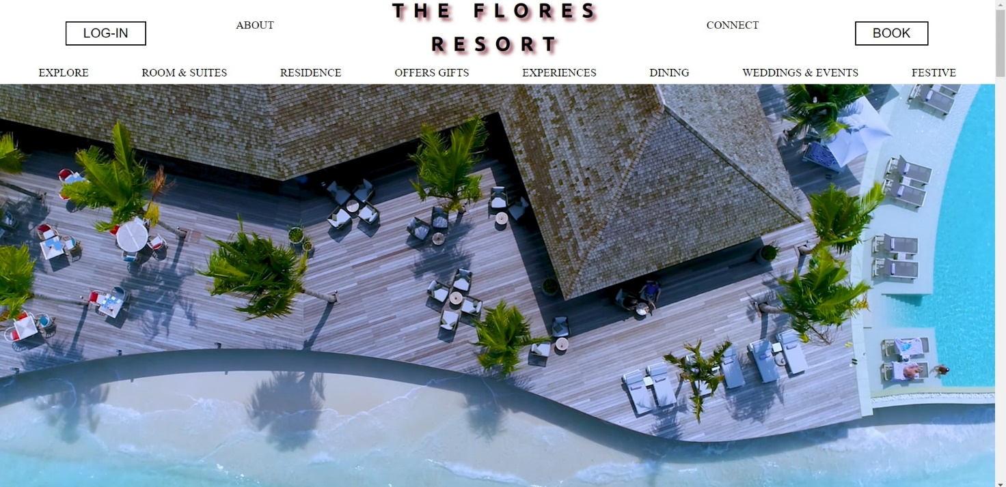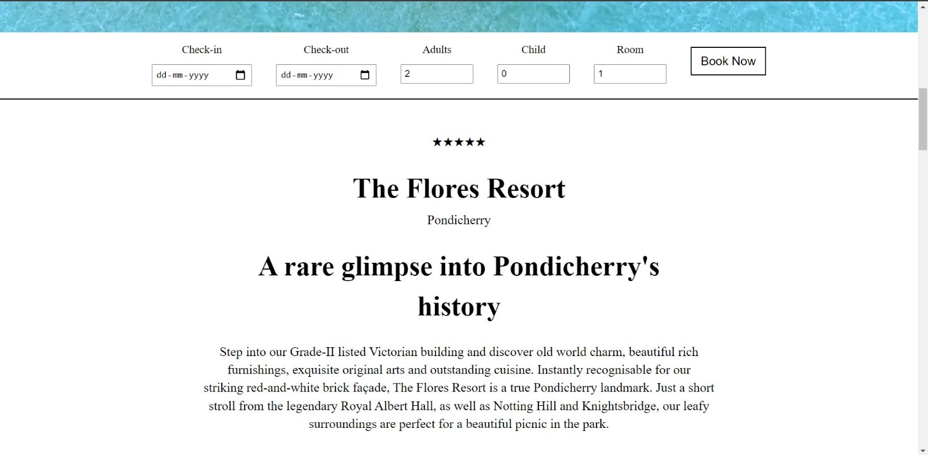

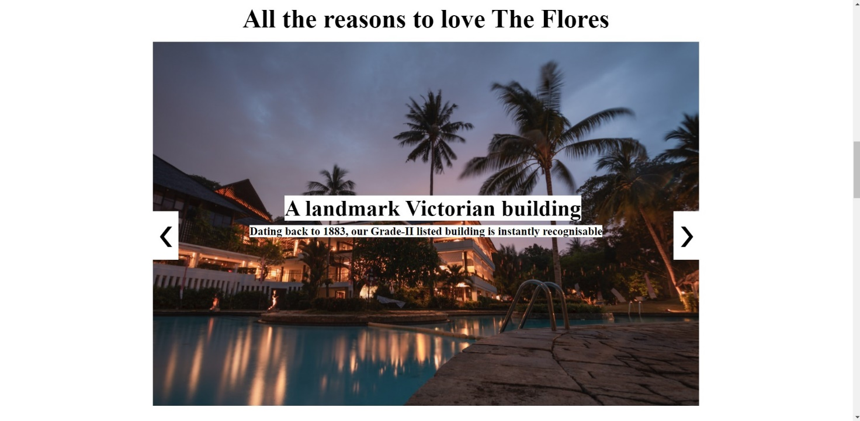
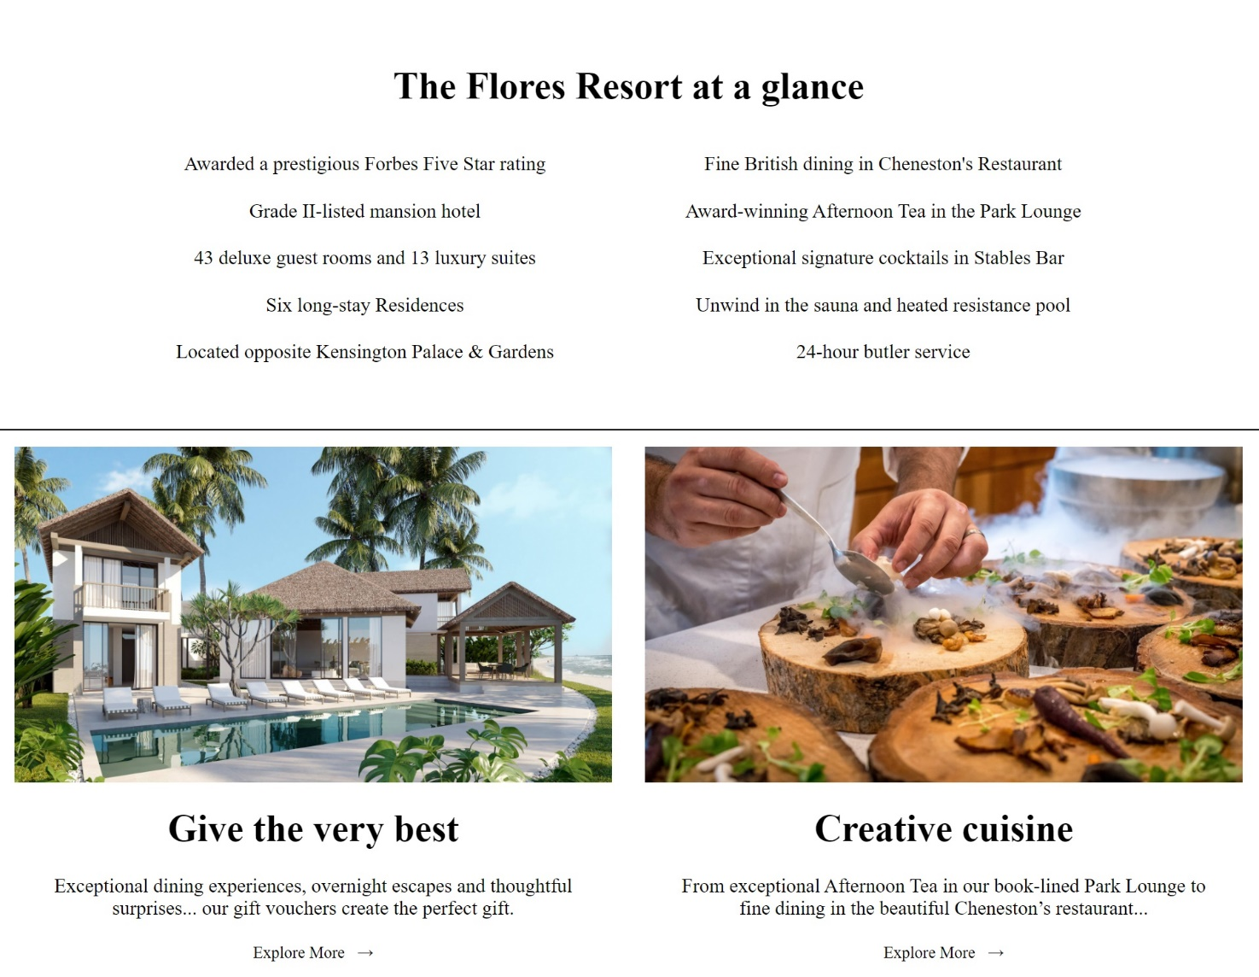

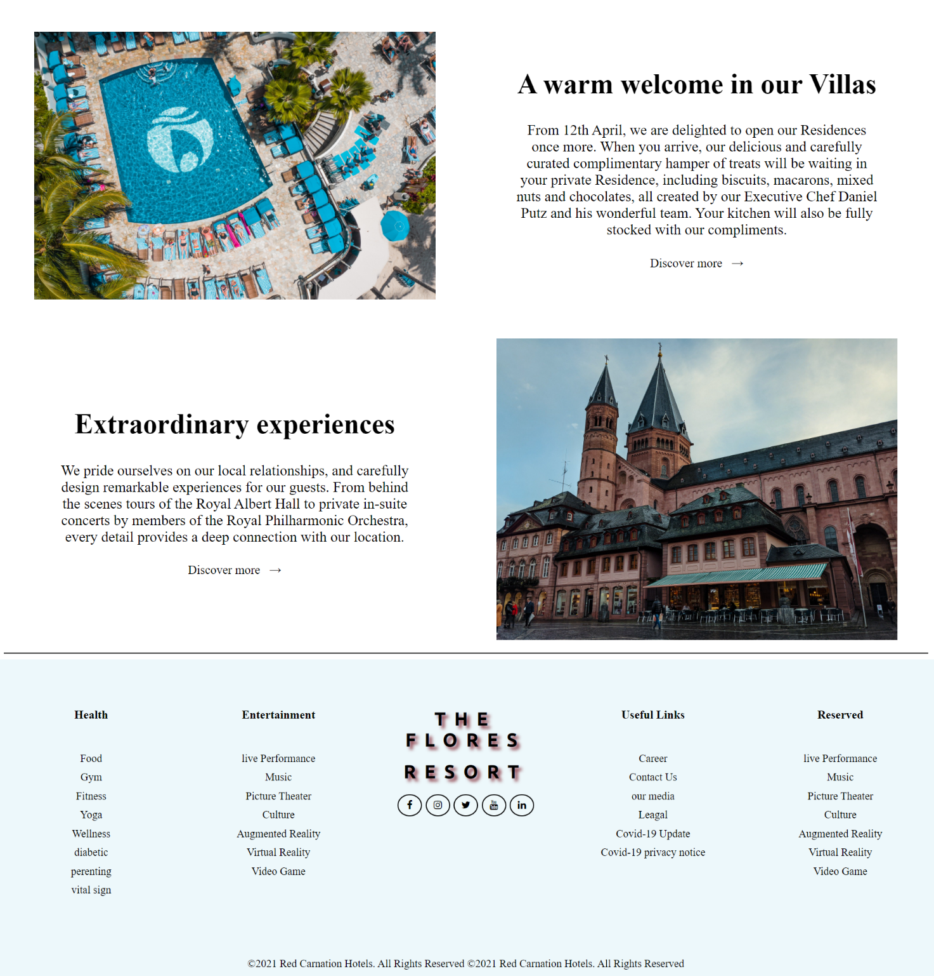

Sign Up Page
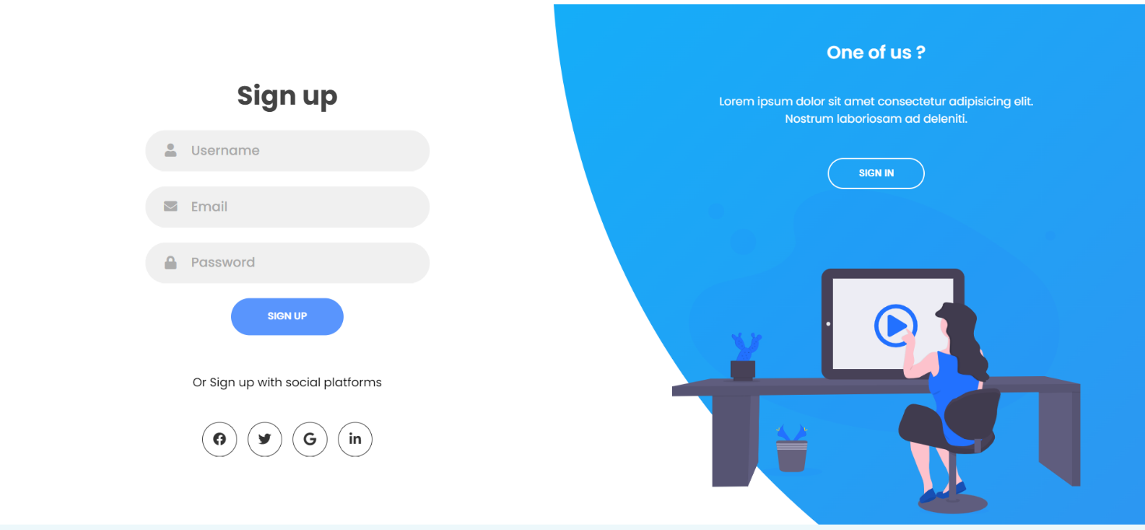

Sign In Page

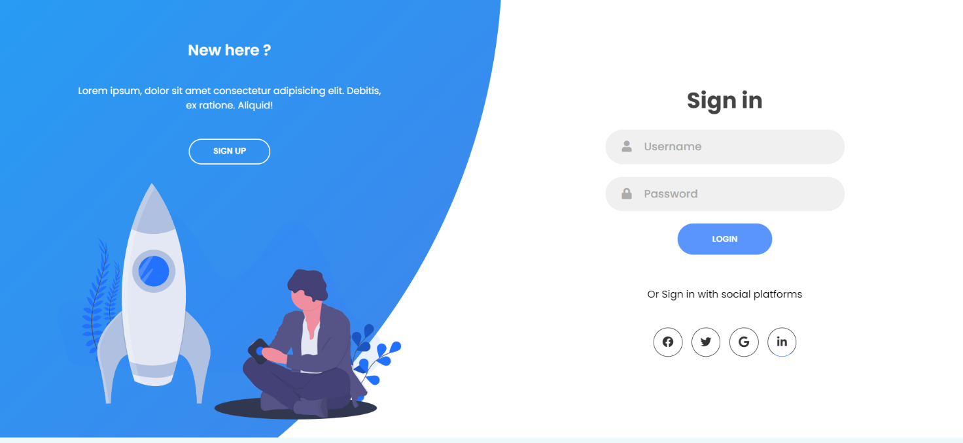

About Us Page
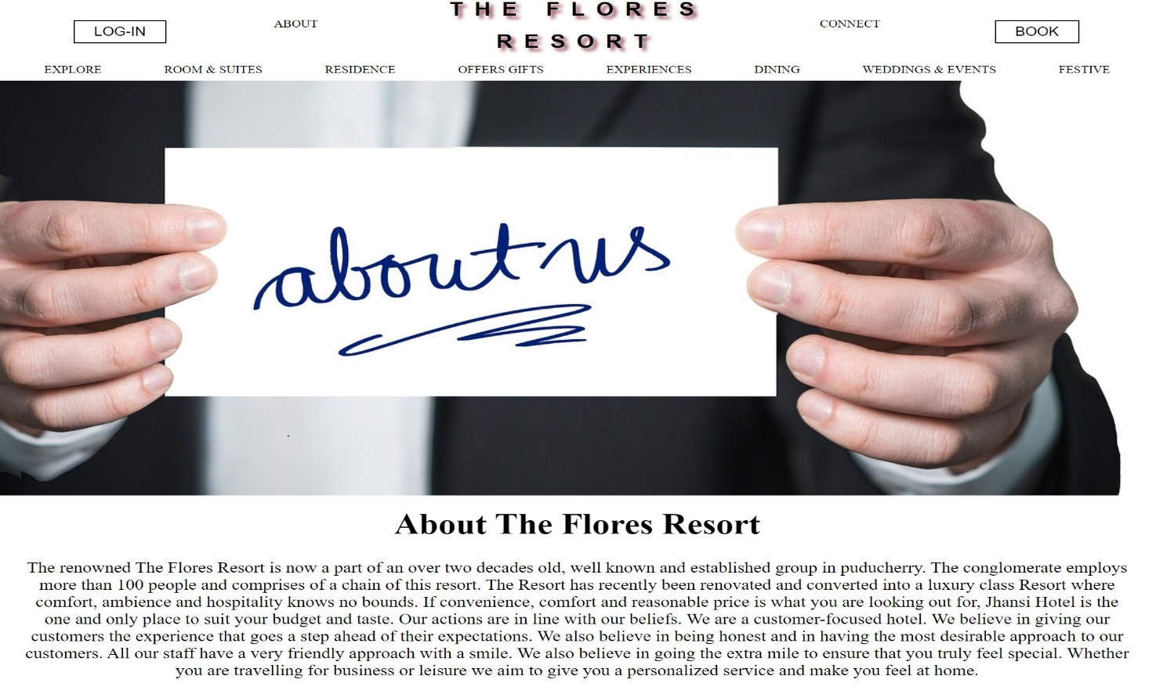
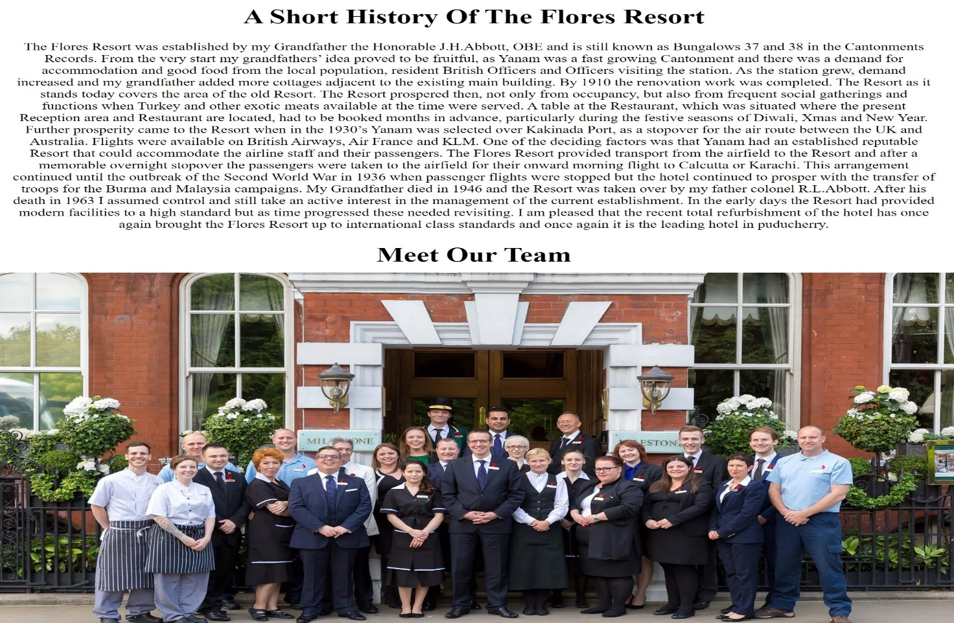

Team Member of Resort



Contact Us Page


